Essay Question:

Read Lines II.34 and II.35 from chapter two of the Yoga Sutra’s of Patanjali. Summerize, in your own words, the meaning of these sutra’s. Explain how they can be used in your life, with people you find difficult, in your practice and in teaching your students.

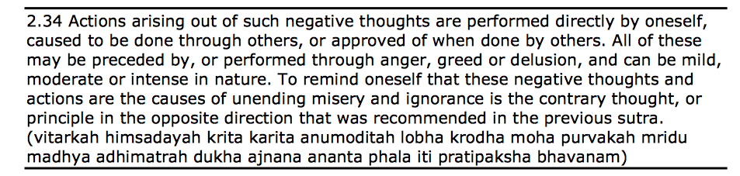

The meaning of this sutra originates from the idea that happiness, health and experience comes from within. Negative thoughts and negative feelings come from thinking about and in this way. This way of thinking leads to a way of living and sooner or later thoughts become actions. This sutra suggests that thinking the contrary thought, which can be thought of as an autonomous meditation and auto-conviction, that we are the masters of ourselves and our lives through niyamas.
Personally, I find this sutra to be fairly central in my life as it is empowering. I gives me agency and thus a certain freedom to be. It allows for proactivity to take action in our life. When faced with difficult people or to challenging experiences, acknowledging the idea that the ability to be happy and healthy comes from within creates a space for acceptance that is essential in any sort of relationship. In my practice and while I teach, I would like to use this sutra by passing on this message of acceptance and personal empowerment: where accepting others and certain situations as they are is not a passive action, but an active one that gives each of us agency in our being as happy beings.

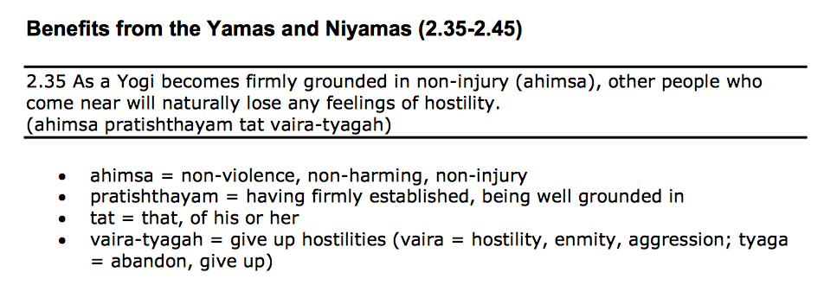

I believe that this sutra refers to a certain kind of subtle energy that we all feel when we relate to each other. An energy that allows us to know, if we listen to it, how the other is feeling and thus who they are. This sutra talks about a Yogi who is at peace with himself, with the world and himself in this world. This is a peace of mind and of being that attracts people who seek this inner and outer peace. And when one is in contact with a person who so evidently shows a kindness and a gentleness that banishes any thought of harm, well they can let down their guard and break the walls that we so easily construct around ourselves in the name of self-preservation.
This sutra is thus an ever-present evolving practice for me. The idea of being at peace with myself and with my life is something I look for throughout my practice of yoga and an atmosphere I would like to create throughout my teaching experiences. As a calm but passionate and curious person, my nature tends to distance myself from this peace and stability. A peace in stability that I consider essential in grounding myself and the relations I have with others, in Earth. Thus brining it to a global and universal dimension.

